EXPERIMENT 2: Chunking

AIM: To design a UI where users recall visual elements (e.g., icons or text chunks). Evaluate the

effect of chunking on user memory.

PROCEDURE:

1. **Create Home Screen:**
   * Add a **1024x768px frame** (File → New Frame).
   * Insert a **title ("Memory Recall Task")** and instructions using the **Text Tool (T)**.
   * Design a **"Start" button** (Rectangle + Text) and link it to the Chunking Phase via **Prototype mode**.
2. **Set Up Chunking Phase:**
   * Create a new **frame** for the chunking display.
   * Add **icons or text** that users need to remember.
3. **Apply Chunking Techniques:**
   * **Chunking with Borders:** Group 3-5 items using **Rectangles (R)**.
   * **Chunking without Borders:** Place items close together without clear separation.
4. **Simulate Viewing Time:**
   * Select the **Chunking Phase frame**, go to **Prototype mode**, and set an **"After Delay" transition (5000ms)** to the Recall Phase.
5. **Create Recall Phase UI:**
   * Add a new **frame** for user input.
   * Add a question: **"Select the items you remember seeing."**
6. **Design Recall Options:**
   * **Multiple-choice method:** Add checkboxes/radio buttons.
   * **Text input method:** Create labeled text input fields (e.g., "Item 1").
7. **Create Submit Button:**
   * Design a **"Submit Recall"** button (Rectangle + Text).
   * Link it to the Result Screen in **Prototype mode**.
8. **Create Result Screen:**
   * Add a **title** (e.g., "Your Recall Score") and feedback text (e.g., "You recalled 4/5 items!").
9. **Provide Analysis:**
   * Test different chunk sizes (3 vs. 5 items) and content types (icons vs. text).
10. **Final Testing & Sharing:**

* Click **Play** to preview the prototype.
* Use the **Share** button to invite testers.

OUTPUT:

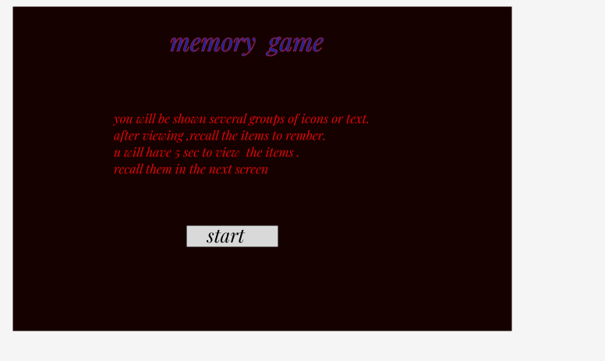

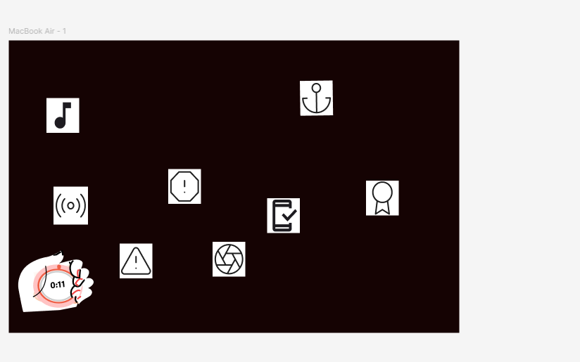

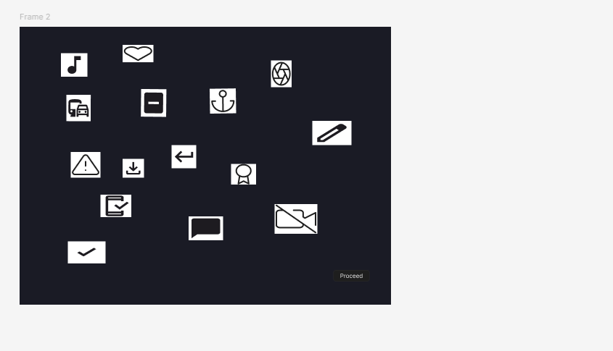

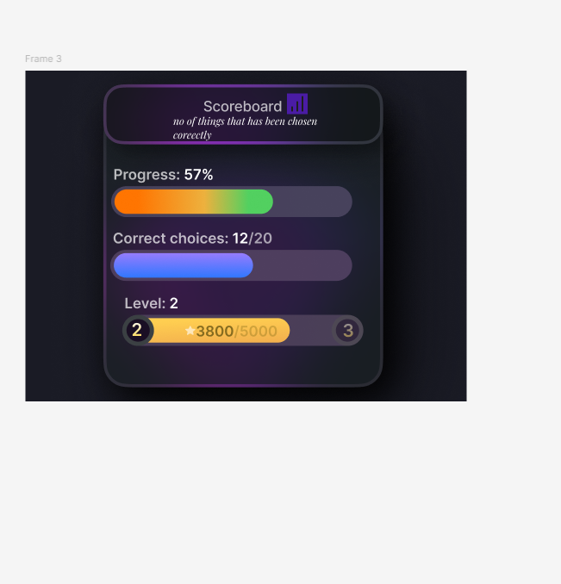

LINK: dev mode

https://www.figma.com/design/rTX0bJNOdK2IMNhkTh2oaE/Untitled?node-id=0-1&m=dev&t=e62mCL9RX5LJQfDz-1

prototype mode

https://www.figma.com/proto/rTX0bJNOdK2IMNhkTh2oaE/Untitled?node-id=0-1&t=e62mCL9RX5LJQfDz-1

RESULT:

The **Memory Recall UI** successfully tests chunking effects by displaying grouped icons/text, prompting recall, and providing feedback on user memory accuracy.